**Classroom Activity​: Write a function to check if a given number is a prime number in js code**

**​**

**Code-**

const num = 29; // You can change this value to test with different numbers

let isPrime = true;

if (num <= 1) {

isPrime = false; // Numbers less than or equal to 1 are not prime

} else if (num <= 3) {

isPrime = true; // 2 and 3 are prime numbers

} else if (num % 2 === 0 || num % 3 === 0) {

isPrime = false; // Eliminate multiples of 2 and 3

} else {

// Check for factors up to the square root of the number

for (let i = 5; i * i <= num; i += 6) {

if (num % i === 0 || num % (i + 2) === 0) {

isPrime = false;

break;

}

}

}

console.log(num + " is prime: " + isPrime);

**Output-**

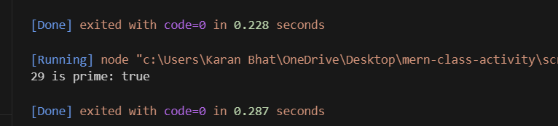

**Execution-Steps:**

* Create a JavaScript file with any name
* Write the code
* Run the code in the terminal using F5 or right click and go to inspect and you can get the output in the console as well.